**DATABASE MANAGEMENT SYSTEM (IT301)**

**Minor Project Report**

on

**Railway Management System**



**National Institute of Technology Karnataka, Surathkal Department of Information Technology**

**Submitted to:** ​​**Dr Anand Kumar**

**Group Members:**

|  |  |
| --- | --- |
| Arun Kumar | 17IT112 |
| Nimit Shah | 17IT139 |
| Vishwanath Sheshagiri Sarathi | 17IT155 |
| Shah Kush Nileshbhai | 17IT238 |

**ABSTRACT**

The Indian Railways (IR) carries about 5.5 lakhs passengers in reserved accommodation every day. The Computerised Passenger Reservation System (PRS) facilitates the booking and cancellation of tickets from any of the 4000 terminals (i.e. PRS booking window all over the countries). These tickets can be booked or cancelled for journeys commencing in any part of India and ending in any other part, with travel time as long as 72 hours and distance up to several thousand kilometres.

In the given project we will be developing a SQLite Database which will help users to find train details, enquire about trains running between given two stations, book tickets and know the exact rates of their tickets to the desired destination.

With the help of online booking people can book their tickets online through internet, sitting in their home by a single click of mouse.

The main objective of the project is management of the database of Railway System. This is done by creating database of the trains between various stations, user database, booking database and many more. The database is then connected to main program using interconnection of the program with the database using Django.

To access this Railway Ticket Booking System Project, users have to register by giving their entire details such as their name, full address details, sex, age, date of birth, nationality, mobile number, email id. After successful registration, users will be provided with their login id and password. The Ticket Management System has applicants and administrators.

Ticket Booking Offices are located in various parts of the state and each office is looked after by administrators. Each administrator has a unique identity, name, address, start date of work at an office in particular location.

**List of Figures**

**TABLE OF CONTENTS**

**ABSTRACT**

**LIST OF FIGURES**

**CHAPTER 1: INTRODUCTION**

1.1 ACTORS

1.2 SOME SAMPLE QUERIES

**CHAPTER 2: SYSTEM DESIGN**

2.1 LOGICAL DESIGN (CONCEPTUAL MODEL)

2.2 SCHEMA DIAGRAM

2.3 ADVANCED LOGICAL DESIGN

2.3.1 NORMALIZATION TECHNIQUES

2.3.2 GLOBAL SCHEMA

2.4 QUERIES

2.4.1 QUERIES TO BE EXECUTED

2.4.2 VIEWS

2.4.3 TRIGGERS

**CHAPTER 3: PHYSICAL DESIGN**

3.1 ASSUMPTIONS

3.2 STORAGE REQUIREMENTS

3.2.1 SPANNED/UNSPANNED RECORDS

3.3 ACCESS METHODS

3.4 TIMINGS

3.5 SYSTEM SPECIFICATIONS

3.6 QUERY COSTS

**CHAPTER 4: IMPLEMENTATION AND RESULTS**

CONCLUSION

REFERENCES

APPENDIX

**CHAPTER 1**

**INTRODUCTION**

**PROBLEM STATEMENT**

Indian Railways (IR) is India's national railway system operated by the Ministry of Railways. It manages the fourth-largest railway network in the world by size, with 121,407 kilometres (75,439 mi) of total track over a 67,368-kilometre (41,861 mi) route. IR runs more than 20,000 passenger trains daily, on both long-distance and suburban routes, from 7,349 stations across India. The trains have a five-digit numbering system. In the freight segment, IR runs more than 9,200 trains daily.

**Pseudo Indian Railway Catering and Tourism Corporation** is a subsidiary of the IndianRailways that handles the catering, tourism and online ticketing operations of the Indian railways, with around 5,50,000 to 6,00,000 bookings everyday is the world's second busiest. It's tagline is "Lifeline of the nation".

It is known for changing the face of railway ticketing in India. It pioneered internet-based rail ticket booking through its website, as well as from the mobile phones via WiFi, GPRS.In addition to e-tickets, Indian Railways Catering and Tourism Corporation also offers I-tickets that are basically like regular tickets.

In the given project we will be developing a SQL Database which will help users to find train details, enquire about trains running between given two stations, book tickets and know the exact rates of their tickets to the desired destination.

With the help of online booking people can book their tickets online through internet, sitting in their home by a single click of mouse.

The main objective of the project is management of the database of Railway System. This is done by creating database of the trains between various stations,user database,booking database and many more. The database is then connected to main program using interconnection of the program with the database using Django

**1.1 Actors**

People who interact with database:

* Admin
* User

**1.2 SOME SAMPLE QUERIES**

Different actors have different access to the database:

* A Admin can
  + Check and edit the list of stations in a country
  + Obtain and edit/add trains between stations.
  + View and also edit the tickets of any user.
  + Change/view the schedule for a train.
  + Generate chart for a specific train for a given journey.
* A User can
  + Get list of ticket that he/she has booked.
  + Book multiple tickets.
  + Also book ticket having each passenger different boarding point.
  + Book ticket from A → C, where no direct train exist from A → C but exist from A → B and B → C.
  + Cancel the ticket he/she has booked.

**CHAPTER 2**

**SYSTEM DESIGN**

**2.1 LOGICAL DESIGN (CONCEPTUAL DESIGN)**

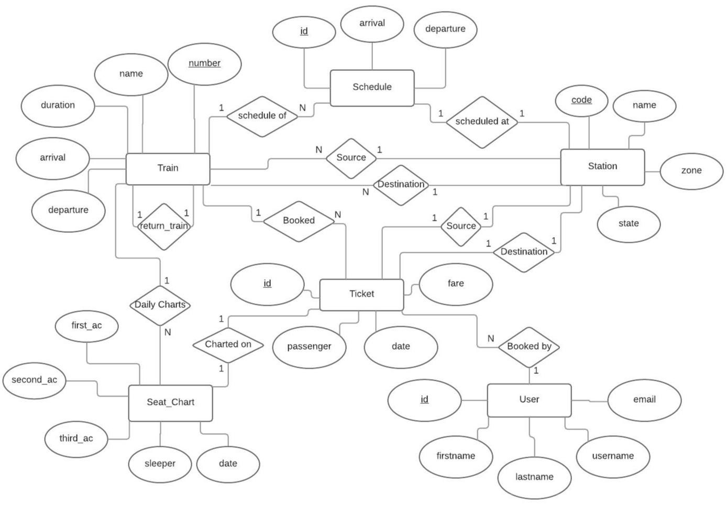

**2.2 SCHEMA DIAGRAM**

Users:

|  |  |  |  |  |  |  |
| --- | --- | --- | --- | --- | --- | --- |
| username | | | email | first_name | last_name | password |
|  |  |  |  |  |  |  |

Station:

board

|  |  |  |  |  |  |  |  |  |  |  |  |  |  |  |  |  |  |  |  |  |  |  |  |  |  |  |  |  |  |  |  |  |  |  |  |  |  |  |  |  |  |
| --- | --- | --- | --- | --- | --- | --- | --- | --- | --- | --- | --- | --- | --- | --- | --- | --- | --- | --- | --- | --- | --- | --- | --- | --- | --- | --- | --- | --- | --- | --- | --- | --- | --- | --- | --- | --- | --- | --- | --- | --- | --- |
| code | | | | | | |  |  |  |  |  |  |  | state | | | |  |  |  |  | name | |  |  |  |  | zone | | |  |  |  | address | | | |  |  |  |  |
|  |  |  |  |  |  |  |  |  |  |  |  |  |  |  |  |  |  |  |  |  |  |  |  |  |  |  |  |  |  |  |  |  |  |  |  |  |  |  |  |  |  |
| Train: | | | | | | |  |  |  |  |  |  |  |  |  |  |  |  |  |  |  |  |  |  |  |  |  |  |  |  |  |  |  |  |  |  |  |  |  |  |  |
|  | |  | |  |  |  |  |  |  |  |  |  |  | |  |  |  |  |  |  |  | |  |  |  |  | |  |  |  |  |  |  |  |  |  |  | | |  |  |
| number | | | | | | |  |  |  |  |  | source | | | | | |  | name | | | | | zone | | | |  |  |  | arrival | |  |  | departure | | | |  |  |  |
|  |  |  |  |  |  |  |  |  |  |  |  |  |  |  |  |  |  |  |  |  |  |  |  |  |  |  |  |  |  |  |  |  |  |  |  |  |  |  |  |  |  |
| return_train | | | | | | | | |  |  |  | dest | | | | | |  | duration_h | | | | | duration_m | | | | | | | type | |  |  | distance | | | |  |  |  |
|  | |  | |  |  |  |  |  |  |  |  |  |  |  |  |  |  |  |  |  |  |  |  |  |  |  |  |  |  |  |  |  |  |  |  |  |  |  |  |  |  |
| Schedule: | | | | | | |  |  |  |  |  |  |  |  |  |  |  |  |  |  |  |  |  |  |  |  |  |  |  |  |  |  |  |  |  |  |  |  |  |  |  |
|  | |  | | |  |  |  |  |  |  |  |  |  |  |  |  |  |  |  |  |  |  |  |  |  |  |  |  |  |  |  |  |  |  | |  |  | | |  |  |
| train | | | | | | |  |  |  |  |  |  |  | station | | | |  |  |  |  | arrival | |  |  |  |  | day | | |  |  |  | departure | | | |  |  |  |  |
|  |  |  |  |  |  |  |  |  |  |  |  |  |  |  |  |  |  |  |  |  |  |  |  |  |  |  |  |  |  |  |  |  |  |  |  |  |  |  |  |  |  |
| Seat_Chart: | | | | | | | | |  |  |  |  |  |  |  |  |  |  |  |  |  |  |  |  |  |  |  |  |  |  |  |  |  |  |  |  |  |  |  |  |  |
|  | | | | |  |  |  |  |  |  | |  |  |  |  |  | |  | |  |  |  |  |  |  |  | |  |  |  | | |  |  |  |  |  |  |  |  |  |
| train | | | | |  |  | date | | | | | | |  |  | second_ac | | | | |  | third_ac | |  | sleeper | | |  |  | first_ac | |  |  |  |  |  |  |  |  |  |  |
|  |  |  |  |  |  |  |  |  |  |  |  |  |  |  |  |  |  |  |  |  |  |  |  |  |  |  |  |  |  |  |  |  |  |  |  |  |  |  |  |  |  |
| Ticket: | | | | | | |  |  |  |  |  |  |  |  |  |  |  |  |  |  |  |  |  |  |  |  |  |  |  |  |  |  |  |  |  |  |  |  |  |  |  |
|  | | | | | |  |  |  |  |  | | |  |  |  |  | |  | |  |  | |  | | |  | |  |  | | | |  |  | | |  | | |  |  |
| passenger | | | | | | |  |  | train | | | | |  |  | type | | chart | |  | user | | source | | | dest | |  | source_schedule | | | |  | dest_schedule | | date | | | | | Board  Schedule |
|  |  |  |  |  |  |  |  |  |  |  |  |  |  |  |  |  |  |  |  |  |  |  |  |  |  |  |  |  |  |  |  |  |  |  |  |  |  |  |  |  |  |

**2.3 ADVANCED LOGICAL DESIGN**

**2.3.1 NORMALIZATION TECHNIQUES**

Every candidate key in a table determines all other attributes and no non-key attributes determine any attributes in the tables. Hence all tables are already in 3rd NF.

4​th​NF is not required since there are no repeated values in any of the tables.

**2.3.1 GLOBAL SCHEMA**



**Users**

|  |  |  |  |
| --- | --- | --- | --- |
| **Attribute name** | **Attribute size** | |  |
|  | **(type in bytes)** | |  |
|  |  |  |  |
| username | char(20) | |  |
|  |  |  |  |
| email | char(20) | |  |
|  |  |  |  |
| first_name | char(10) | |  |
|  |  |  |  |
| last_name | char(10) | |  |
|  |  |  |  |
| password | char(20) | |  |
|  |  |  |  |
|  | | |  |
| **Stations** | | |  |
|  |  |  |  |
| **Attribute name** |  | **Attribute size** |  |
|  |  | **(type in bytes)** |  |
|  |  |  |  |
| state |  | char(20) |  |
|  |  |  |  |
| code |  | char(10) |  |
|  |  |  |  |
| name |  | char(30) |  |
|  |  |  |  |
| zone |  | char(10) |  |
|  |  |  |  |
| address |  | char(50) |  |
|  |  |  |  |

**Train**

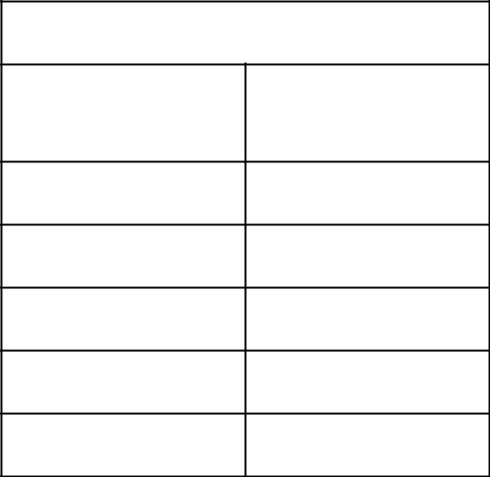

**Attribute name Attribute size (type in bytes)**

arrival char(8)

source char(10)

name char(30)

zone char(10)

number char(15)

|  |  |  |
| --- | --- | --- |
|  | **Schedule** | |
|  |  |  |
| **Attribute** |  | **Attribute size (type in** |
| **name** |  | **bytes)** |
|  |  |  |
| arrival |  | char(8) |
|  |  |  |
| day |  | int |
|  |  |  |
| train |  | char(15) |
|  |  |  |
| station |  | char(10) |
|  |  |  |
| id |  | int |
|  |  |  |
| departure |  | char(8) |
|  |  |  |

|  |  |
| --- | --- |
| **Ticket** | |
| **Attribute Name** | **Attribute Size (types in bytes)** |
| Passenger | char(20) |
| Train | char(15) |
| Type | char(2) |
| Board | char(10) |
| Board_schedule | int |
| Chart | int |
| User | char(20) |
| Source | char(10) |
| Dest | char(10) |
| Source_schedule | int |
| Dest_schedule | int |
| Date | date |
| Fare | int |

|  |  |  |
| --- | --- | --- |
|  | **Seat_Chart** | |
|  |  |  |
| **Attribute** |  | **Attribute size (type in** |
| **name** |  | **bytes)** |
|  |  |  |
| train |  | char(15) |
|  |  |  |
| first_ac |  | int |
|  |  |  |
| second_ac |  | int |
|  |  |  |
| third_ac |  | int |
|  |  |  |
| sleeper |  | int |
|  |  |  |
| date |  | date |
|  |  |  |

**2.4. QUERIES**

**2.4.1** ​​**Queries to be executed:**

1. **User login.**

SELECT * FROM Users WHERE username = input_name AND password =

password;

1. **Search for trains.**

SELECT * FROM trainDetails

1. **Book Tickets.** INSERT INTO Ticket

(input_name,input_train,input_seat_type,input_chart,user.username,input_source,in put_dest,input_sourceSchedule,input_destSchedule, input_date,fare)

1. **View previous bookings**

SELECT * FROM Ticket WHERE user = cookie_user;

1. **Cancel Bookings** DELETE FROM Ticket

WHERE user = cookie_user AND id = input_id;

**2.4.2 VIEWS**

CREATE view trainDetails AS

SELECT t.name, t.number, s1.name, s2.name, sc1.departure, sc2.arrival, sch.seats FROM Train t

JOIN Station s1 on s1.code=input_source

JOIN Station s2 on s2.code=input_dest

JOIN Schedule sc1 on sc1.station=s1.code AND sc1.train=t.number

JOIN Schedule sc2 on sc2.station=s2.code AND sc2.train=t.number

JOIN Seat_Chart sch on t.number=sch.train AND sch.date=input_date

WHERE sc1.departure < sc2.arrival

**2.4.3 TRIGGERS**

1. **For booking tickets:**

DROP TRIGGER IF EXISTS book_ticket;

DELIMITER //

CREATE TRIGGER book_ticket AFTER INSERT ON Ticket

FOR EACH ROW BEGIN

Update Seat_Chart Set seats=seats-1

WHERE

train=NEW.train AND date=NEW.date

1. **For cancelling tickets:**

DROP TRIGGER IF EXISTS cancel_ticket;

DELIMITER //

CREATE TRIGGER cancel_ticket AFTER DELETE ON Ticket

FOR EACH ROW BEGIN

Update Seat_Chart Set seats=seats+1

WHERE

train=OLD.train AND date=OLD.date

**CHAPTER 3**

**PHYSICAL DESIGN**

**3.1 ASSUMPTIONS**

**Number of tuples in each relation**

|  |  |
| --- | --- |
| User | 1000 |
| Train | 2000 |
| Station | 10000 |
| Schedule | 20000 |
| Seat_Chart | 60000 |
| Ticket | 80000 |

**3.2 STORAGE REQUIREMENTS: DISK PARAMETERS**

Avg Seek Time

Rotational Delay(Latency time)

Block Transfer Time

Block pointer size

Block Size

Following are the assumptions which are considered for storage requirements:

* Fixed length records are considered for all relations.
* The delimiter for each field is length of the field
* Total number of records in respective relations (provided in below table).
* Block size is 1024 bytes.
* Record doesn’t span over multiple blocks (this can be achieved by taking floor function during calculating number of records per block to restrict single record doesn’t span over blocks).
* Block pointer(Bp) size is 4 bytes
* Average Seek Time(S) is 20 ms irrespective of any site.
* Average Disk rotation time (Latency) Time (L) is 10 ms irrespective of any site.
* Block transfer rate (Tr) is 0.5 ms irrespective of any site.
* **Blocking factor= ceil(Block size /**​**Record**​ **size in bytes)**
* **# no of blocks = ceil(# of records/ Blocking factor)**

|  |  |  |  |  |  |
| --- | --- | --- | --- | --- | --- |
| **Relation** | **# of** | **Record size in bytes** | **Blocking** | **# no. of blocks** |  |
| **records** | **factor** |  |
|  |  |  |  |
| User | 1000 | 80 | 12 | 84 |  |
| Train | 2000 | 123 | 8 | 250 |  |
| Station | 10000 | 120 | 8 | 1250 |  |
| Schedule | 20000 | 49 | 20 | 1000 |  |
| Seat_Chart | 60000 | 40 | 25 | 2400 |  |
| Ticket | 80000 | 100 | 10 | 8000 |  |

Total number of blocks used = 84+250+1250+1000+2400+8000 = 12,984 blocks

**3.3 ACCESS METHODS:**

Considering the assumption we can calculate easily the size of single record (tuple) of every relation with the help of Schema. The above table gives the number of records in each relation, size of each record, blocking factor for a particular block of that relation and number of blocks required to store entire relation.

Having records on secondary storage, if you want to access them faster, then you need indexing. If a database is frequently queried and it is too large then it is supposed to have index to increase performance. There are various indexes used in databases. Here, we consider the following indexing scheme: Primary Index, Clustered Index and Secondary index. Based on the query, we decide what type of indexing file.

|  |  |  |  |
| --- | --- | --- | --- |
| **Relation** | **Indexing type** | **Indexing attribute(s)** | **Is a key?** |
|  |  |  |  |
| User | Primary | Username | Yes |
|  |  |  |  |
| Train | Primary | Number | Yes |
|  |  |  |  |
| Stations | Primary | Code | Yes |
|  |  |  |  |
| Schedule | Primary | Id | Yes |
|  |  |  |  |
| Seat_Chart | Primary | { Train, Date } | Yes |
|  |  |  |  |
| Ticket | Primary | { User, Train, Date } | Yes |
|  |  |  |  |

The following table explains what is the disk block access time to extract particular record for all the relations.

|  |  |  |  |  |  |  |  |  |
| --- | --- | --- | --- | --- | --- | --- | --- | --- |
| **Relation** | **# of** | **# no of** | **Index** | **# of** | **# no of** | **# no of** | **# no of** |  |
|  | **records** | **data** | **size** | **index** | **index** | **block** | **block** |  |
|  |  | **blocks** | **per** | **records** | **blocks** | **access** | **access** |  |
|  |  |  | **record** | **per** |  | **with** | **with** |  |
|  |  |  |  | **block** |  | **indexing** | **indexing** |  |
|  |  |  |  |  |  |  |  |  |
| User | 1000 | 84 | 24 | 42 | 24 | 84 | 6 |  |
|  |  |  |  |  |  |  |  |  |
| Train | 2000 | 250 | 19 | 53 | 38 | 250 | 6 |  |
|  |  |  |  |  |  |  |  |  |
| Stations | 10000 | 1250 | 14 | 73 | 137 | 1250 | 8 |  |
|  |  |  |  |  |  |  |  |  |
| Schedule | 20000 | 1000 | 8 | 128 | 157 | 1000 | 8 |  |
|  |  |  |  |  |  |  |  |  |
| Seat_Cha | 60000 | 2400 | 27 | 37 | 1622 | 2400 | 12 |  |
| rt |  |  |  |  |
|  |  |  |  |  |  |  |  |
|  |  |  |  |  |  |  |  |  |
| Ticket | 80000 | 8000 | 47 | 21 | 3810 | 8000 | 13 |  |
|  |  |  |  |  |  |  |  |  |

* of index records per block= Block size / Index size per record
* no of index blocks =ceil( # of records / # of index records per block)
* no of block access without indexing = # no of data blocks

number of block accesses with indexing = ceil [log(# no of index blocks)] + 1

Indexing the data file definitely reduces the number of block accesses needed to find particular record from the data file. The complete statistics is shown in above table.

**3.4 TIMINGS**

Disk access time = Average seek time + latency time + block transfer time

* 20+10+0.5
* 30.5 ms

Therefore, to access one random block and transfer it, the time is 30.5ms.

If the blocks are consecutive seek time and latency time are not included.

Also, there can be overhead delay and queuing delay

**CHAPTER 4**

**IMPLEMENTATION AND RESULTS**

**1. Login Form**

**2. Signup Form**

**3. Search Trains**

**4. Display Train and Available Trains**

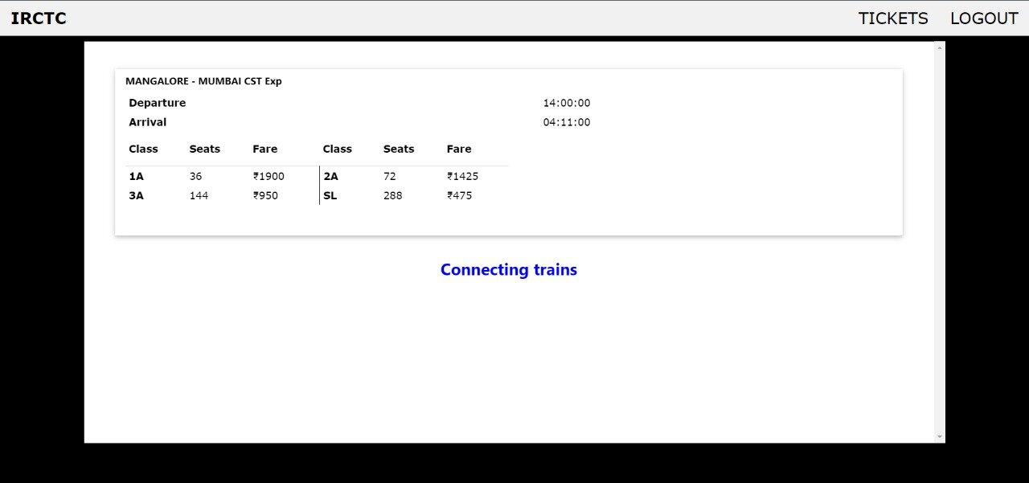

**5. Display Connecting Trains**

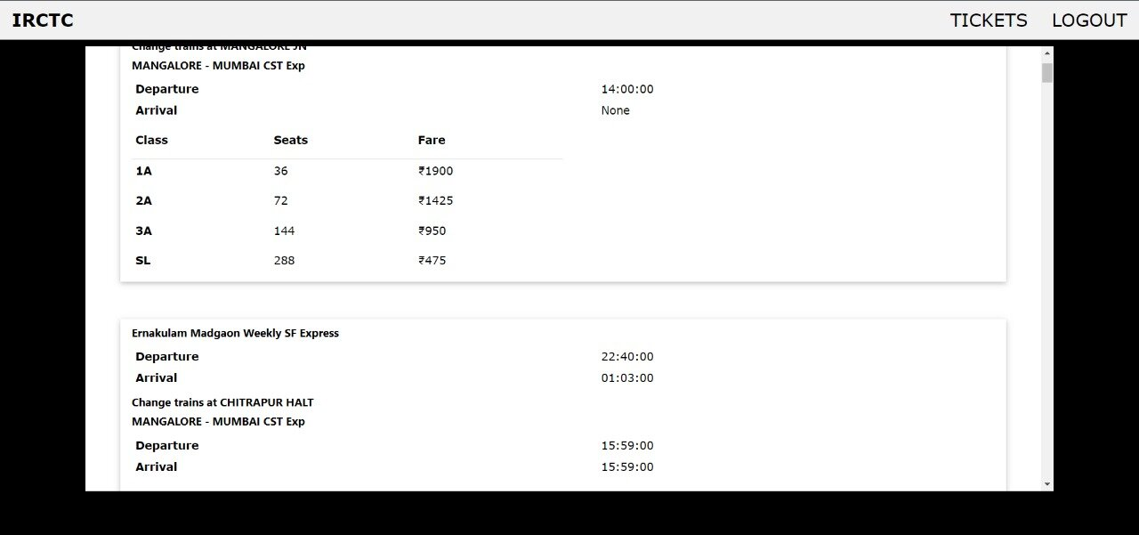

**6. Booked History**

**7. Admin Login**

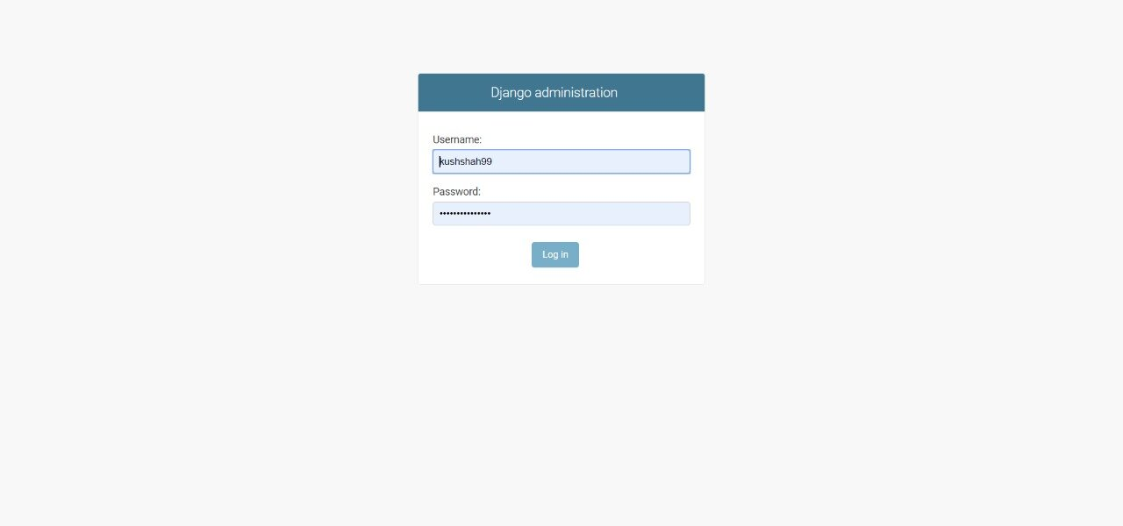

**8. Admin Account**

**CONCLUSION**

Indian Railway Catering and Tourism Corporation (IRCTC) is a subsidiary of the Indian Railways that handles the catering, tourism and online ticketing operations of the Indian railways, with around 5,50,000 to 6,00,000 bookings everyday is the world's second busiest. It's tagline is "Lifeline of the nation". It is known for changing the face of railway ticketing in India. Databases are used to support internal operations of organizations and to underpin online interactions with customers and suppliers. Databases are used to hold administrative information and more specialized data, such as engineering data or economic models. Examples include computerized library systems, flight reservation systems, computerized parts inventory systems, and many content management systems that store websites as collections of webpages in a database. We have tried to implement a part of IRCTC and it has helped us to understand how Database is managed in the website.

**REFERENCES**

1. <https://en.wikipedia.org/wiki/Indian_Railway_Catering_and_Tourism_Corporation>
2. <https://www.irctc.co.in/nget/train-search>
3. <https://data.gov.in/keywords/indian-railways>
4. <http://api.erail.in/>
5. <https://railwayapi.com/>
6. <https://indianrailapi.com/>
7. <https://www.programmableweb.com/api/indian-railways>
8. <https://data.gov.in/resources/indian-railways-time-table-trains-available-reservation-03082015/api>

**APPENDIX**

**Description of tool**

Application Tools

* Database: MySQL
  + MySQL has proved to be the database for web based applications, because of its performance and scalability, reliability, availability. From the perspective of a database administrator, it’s perfectly reliable and easily maintainable.
* Backend Framework : Django
  + Django encourages clean, practical way of designing highly customizable applications.
  + It is a very reliable, efficient, architecturally sound and secure when building web apps.
* Frontend Tools : HTML, CSS, JavaScript
  + HTML stays the markup language for creating web pages and web applications.
  + CSS is the stylesheet language for styling the documents.
  + JavaScript is the front end scripting language.
* Visual Studio Code
  + Visual Studio Code provides smart code completion, code inspections, on-the-fly error highlighting and quick-fixes with automated code refactorings and rich navigation capabilities.